COVID-19 Live Dashboard

**Overview**

This project delivers a real-time COVID-19 dashboard powered by a complete data pipeline. The system fetches global COVID-19 statistics hourly using the [Disease.sh](https://disease.sh/) API, stores the data in a PostgreSQL database, and visualizes it using Microsoft Power BI.

**Architecture Diagram  
  
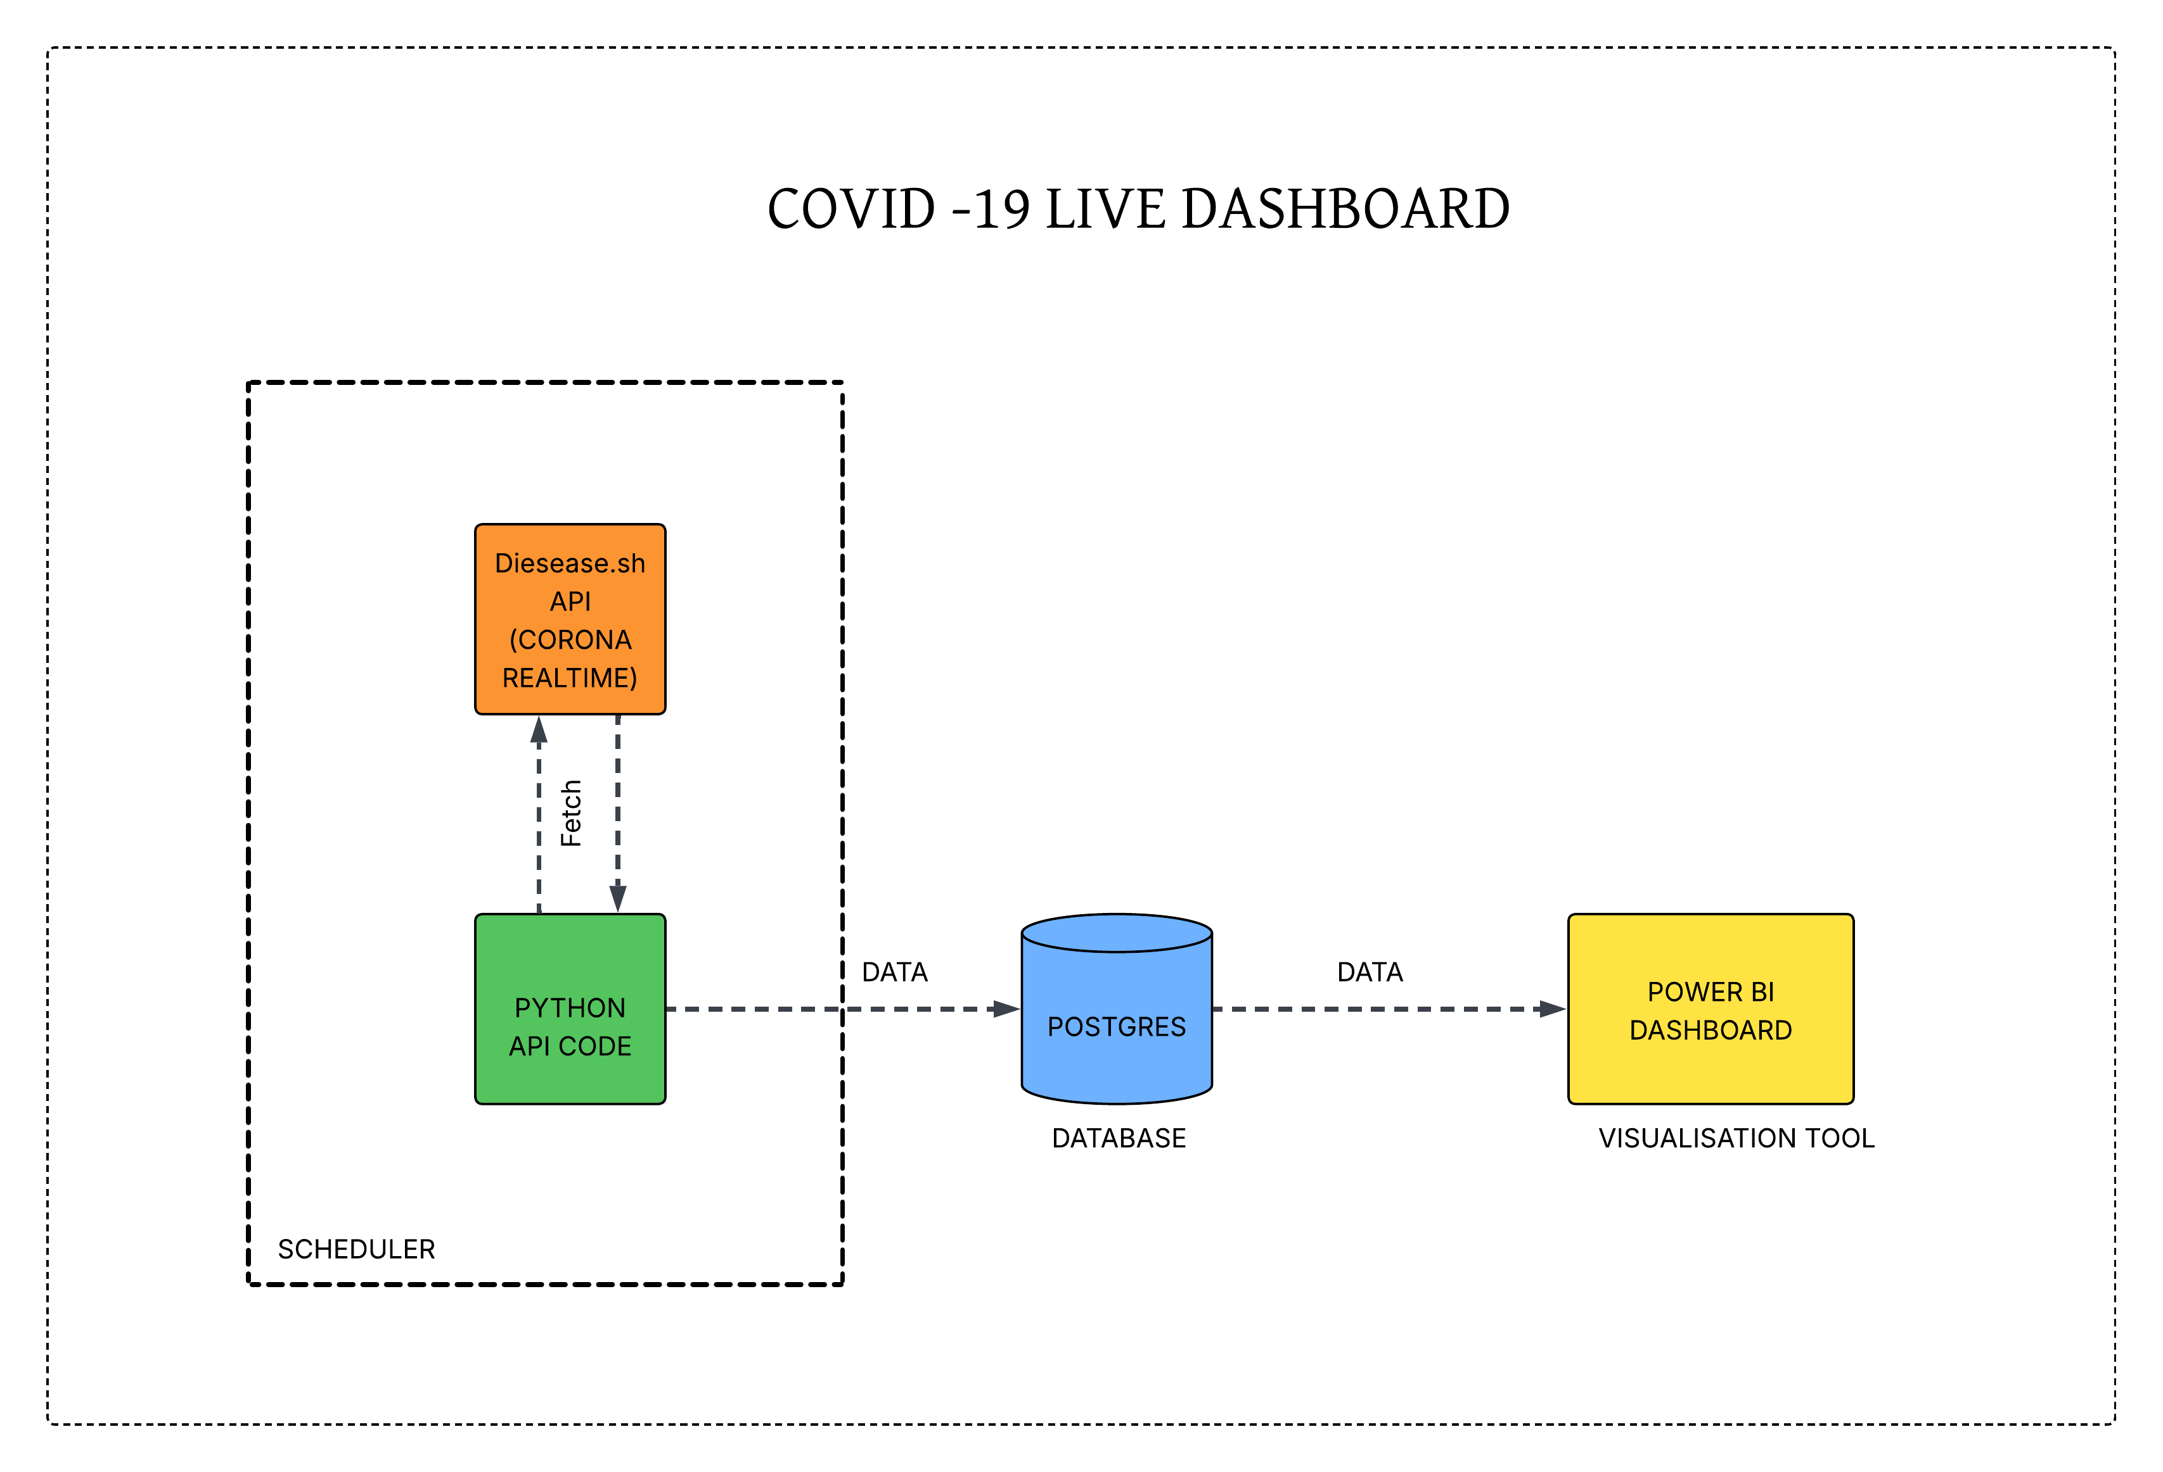**

**Technology Stack**

* **Data Source:** [**Disease.sh API**](https://disease.sh/v3/)
* **Backend Script: Python**
* **Data Cleaning: pandas**
* **Scheduler: APScheduler**
* **Database: PostgreSQL**
* **Visualization: Power BI**

**Python Script Details**

**File: hourly_api.py  
This script performs the following:**

* **Fetches data every hour from the Disease.sh API.**
* **Cleans the data by selecting and renaming relevant fields.**
* **Adds timestamps (last_updated, fetch_time) for auditing.**
* **Stores the data in a PostgreSQL table (covid_stats), overwriting each time for freshness.**

**Python Libraries Used:**

**- requests For API calls**

**- pandas For data manipulation**

**- datetime For timestamps**

**- SQLAlchemy For PostgreSQL integration**

**- APScheduler For hourly scheduling**

**Database Schema**

Table: covid_stats

| **Column** | **Description** |
| --- | --- |
| country | Country name |
| cases | Total confirmed cases |
| today_cases | Cases reported today |
| deaths | Total deaths |
| today_deaths | Deaths reported today |
| recovered | Total recovered patients |
| active | Currently active cases |
| critical | Critical condition cases |
| cases_per_million | Cases per 1 million population |
| deaths_per_million | Deaths per 1 million population |
| tests | Total tests conducted |
| tests_per_million | Tests per 1 million population |
| population | Country population |
| continent | Continent |
| last_updated | API's last updated time |
| fetch_time | Time the API was fetched |

**Visualization in Power BI**

* Power BI connects directly to the PostgreSQL covid_stats table.
* Dashboards include:
  + Global and country-wise case trends
  + Daily new cases and deaths
  + Comparisons across continents
  + Testing statistics**File**: Covid_live.pbip

**Sreenshot of the Dashboard**

**Conclusion**

This system is fully automated and scalable. It can be adapted for additional data enrichment (e.g., vaccination stats), time-series analysis, or alert systems.